Headline: For the litigation teams who rely on medical insight and testimony.
Subhead: Medical Intelligence Services — record analysis, physician reports, and expert testimony.

The epigraph
Knowledge itself is power. — Francis Bacon

The cards
Three cards in a row, each a full-card click. The QME button sits apart top right corner.
Card | Line under the name | One line of detail | Goes to
Merlin | Physician-grade command of the complete record | The whole production, read and analyzed. Not just a chronology. | merlin.law
Guardian Medical Advisory | Substantiated medicine for the cases that settle | Lower-cost generalist opinion on causation, future care, and other areas of dispute. | guardianadvisory.group
Guardian Civil Services | Specialists who hold up under challenge | Board-certified experts for trial cases and independent evaluations. | guardiancivil.services

Card copy, as it appears
Merlin
Physician-grade command of the complete record.
The whole production, read and analyzed. Not just a chronology.
Explore Merlin →
Guardian Medical Advisory
Substantiated medicine for the cases that settle.
Lower-cost generalist medical opinion on causation, future care, and other areas of dispute.
Learn more →
Guardian Civil Services
Board-certified specialists who hold up under challenge.
Retained experts for trial cases and independent evaluations.
Learn more →

The QME button
Separate from the three cards button in the top right corner which goes to legacy www.theguardian.group

The pyramid
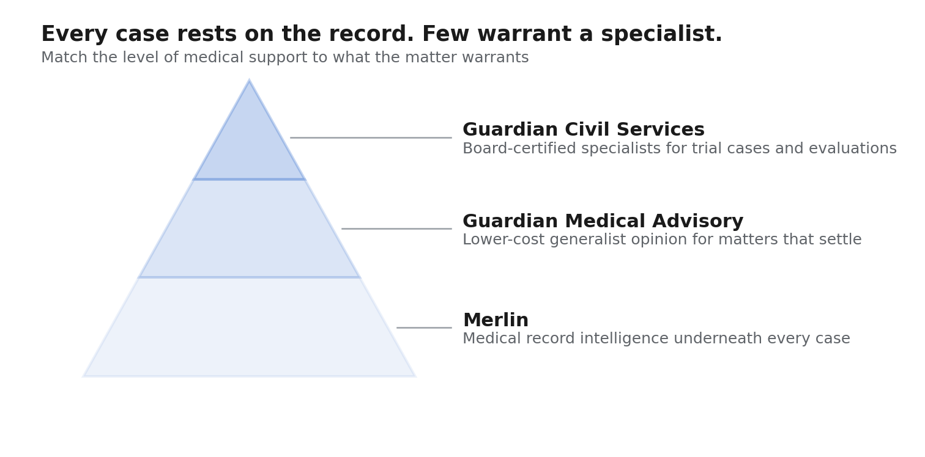
The pyramid: three tiers, Merlin at the foundation
Width carries the meaning: Merlin applies to every file, Medical Advisory to the matters that need an opinion, Civil Services to the few that warrant a specialist.

Using it on the page
The pyramid can replace the three cards or sit above them. Replacing them is the stronger version — it makes the argument the cards only imply, which is that these are levels of one service rather than three separate vendors.
Each tier should be clickable, going to the same destinations the cards did. The QME button stays where it is, separate and below.
Heading above it: Match the medicine to the matter.
Line beneath it: Every case rests on the record. Few warrant a specialist. Most sit somewhere in between.la

